
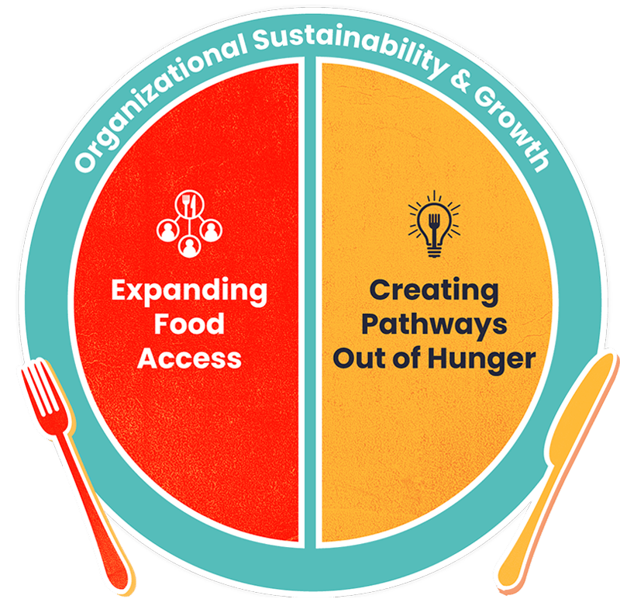
Food bank to food larder sustainability report

Contents
Introduction 2
Purpose of this review 5
Challenges with the current model 6
Current Position – West Northants 6
Food Aid Models 9
Research for this paper 10
Observations during the visits 11
1. The current food aid models and provisions: 11
2. Sustainability of the VCSE Sector food aid organisations: 13
3. Holistic support: 14
Conclusions 16
Appendices 17

Introduction

This report has been commissioned by the Anti-Poverty Steering Group of West Northants Council addressing how to use future funding to improve the food pathway supporting those who find themselves in need of crisis support via a food bank. It will identify what the current position is and what support is needed to ensure the client is no longer in crisis and using the appropriate agencies to support this journey out of crisis.

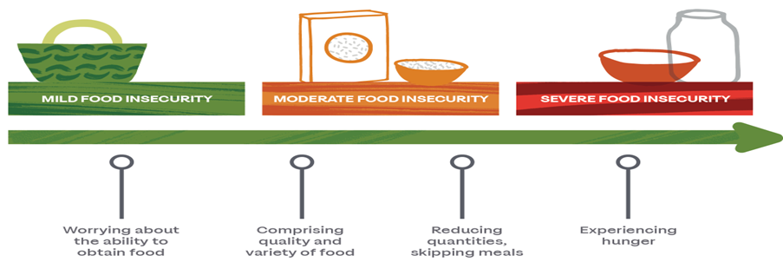
Food and nutrition insecurity are predominantly influenced by the local environment, including surrounding community infrastructure, accessibility, and affordability barriers. Access to shops that carry healthy food options (such as fresh fruit, vegetables, low-fat fish and poultry) are not located equitably across urban and rural areas in West Northamptonshire.

Food insecurity, as illustrated in the figure above is wide ranging and is a serious public health issue that affects us in West Northamptonshire, it can have many negative effects on health, including:

- Chronic diseases: Food insecurity is linked to an increased risk of chronic diseases like diabetes, cardiovascular disease, and certain cancers.
- Mental health: Food insecurity can lead to mental health disorders like depression and anxiety.
- Obesity: Children who are food insecure are more likely to grow up obese, which can lead to other health problems like heart disease, cancer, and arthritic problems.
- Dental decay: Food insecure children are more likely to have dental decay, which can cause pain and damage that lasts a lifetime.
- Maternal depression: Mothers with young children who are food insecure are more likely to experience depression, which can negatively impact their children's health.
- Premature mortality: Food insecurity is associated with a higher risk of premature mortality.
- Malnutrition: Going hungry can lead to malnutrition, fatigue, and decreased immunity.
Food insecurity refers to the situation in which an individual does not have access to enough safe and nutritious food to support normal development and growth whilst food vulnerability is based on combining benefits claimed and household-level insecurity (i.e., living alone as an older person, low-income households) (Smith et al., 2018 cited in Local Insight (Oxford Consultants for Social Inclusion), 2023).

Food insecurity is an issue in the United Kingdom, with data illustrated 4.7 million people (7%) in the UK live in food insecure households (Francis-Devine, Malik and Danechi, 2023). In 2021, the percentage of the population living in the areas of highest risk of food insecurity was (15.3%) West Northamptonshire (Public Health England, 2023).

During Covid VCSE organisations delivering food aid in West Northamptonshire joined together to create an umbrella body called Food Aid Alliance West Northants (FAAWN). FAAWN is a network of VCSE Sector food banks, larders and clubs based in West Northamptonshire. The members supported each other to access food and funding, it also works to share best practice, share surplus food, and to help identify funding to support its member organisations to continue to deliver food to the growing number of people needing support. FAAWN has 36 member sites in urban and rural West Northants. Ten of these sites have been operating a paid provision for over 12 months and four have started to charge in the last twelve months.

During Covid demand for food aid grew dramatically, but not always due to financial hardship. The focus was often people being unable to access food due to having Covid or being categorised as ‘vulnerable’ and unable to go to the shops. We also saw massive challenges with transportation and logistics of food due to national restrictions, thus limiting food availability.

The Covid Pandemic pushed the focus for public support around food to the forefront (see appendix 1), it also highlighted the everyday challenges that people living in financial hardship are facing and struggling to find support e.g. debt and money support, employability, immigration, SEND, adult social care, housing, benefits, etc. The scale of the numbers using food aid in West Northants has grown significantly, Hope was seeing: 150 pre pandemic, over 500 during and now, over 800 people per week. The need for wider support has pushed the VCSE Sector and the support they are providing to breaking point.

Previous research has found that most people using food banks in the community are destitute and, even before the pandemic, the number of people struggling to make ends meet was increasing. This crisis has landed after years of stagnant wages and frozen, capped working age benefits - leaving those on the lowest incomes vulnerable to income shocks. The pandemic reshaped the landscape, yet neither the war in Ukraine nor the cost-of-living crisis has deterred the third sector from supporting our local communities.

Surging food prices were one of the key factors driving inflation through 2022 and 2023, as well as one of the most visible signals to consumers of the cost-of-living crisis. At one point, the annual inflation rate for food products was an extraordinary 19%, hitting shoppers hard every time they filled up a basket.

Prices have been pushed up because of the significant input cost pressures faced by retailers due to rising commodity and energy prices and a tight labour market. Even the price of basic items went up, with the price of the humble cuppa rising, as teabags, milk and sugar all saw significant rises. While some supply chain costs are beginning to fall, this is more than offset by the cost of energy, meaning a difficult time ahead for retailers and households alike. These events have pushed fuel, food and borrowing money up which is affecting everyone. Despite a rise in public demand for services, FAAWN members continue to work tirelessly, adapting to constantly shifting goals. Appendix 1 demonstrates through the 2021/22 Trussell Trust report some of these challenges and the pre and post pandemic food bank support nationally.

More recently, affordable food larders have emerged as a means of seeking to provide a more sustainable, dignified response to food insecurity. Dignity is offered through the choice of payment, with members benefiting from access to healthy food, financial saving and a focus on social connections in the community. Food insecurity remains a persistent challenge in the UK, affecting 13.6% of households as of June 2024, with families and children particularly
vulnerable.

In response to this the Voluntary, Community and Social Enterprise Sector (VCSE) has expanded its food aid provision rapidly in the last ten years, but most significantly during and following the Covid pandemic. Much of the funding that FAAWN accessed for its members to purchase food came through West Northamptonshire Council (WNC) through ‘Star Fund’ and ‘Household Support Fund’. Due to the growing demand on the organisations in FAAWN for crisis food support, the organisations have become more and more reliant on WNC funds to keep the services going, with the majority of organisations running the provision having no choice but to focus their time and effort on delivering food aid. This has limited their time available to collect food donation, accessing wider funding or to focus on individual client/customer needs (i.e. ‘wraparound’ support).

Wraparound support is a comprehensive plan of support that is created by a team of service providers and key people in an individual's life. The plan is designed to meet the individual's needs and can include a variety of services, such as:
- Mental health care
- Employment assistance
- Housing support
- Behavioural health services
- Medical support
- Financial assistance
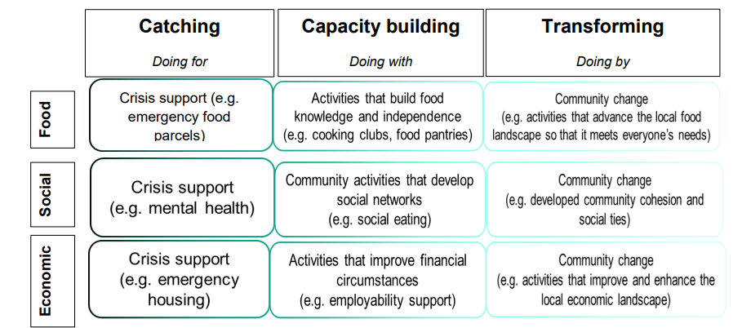

Purpose of this review

The aim of this review is to understand the pathway clients take from crisis food aid to independent living, and how this can be a tailored more to supporting people on the wider issues of poverty and not just on food provision. The review will address three key areas:

- The current food aid provisions:
  - Reviewing whether we have the correct services in place in the right parts of West Northants.
  - Understand the types of food-aid organisations that exists.
  - Understand the place of highest need (free school meals, Indices of multiple deprivation).

- Sustainability of the VCSE Sector food aid organisations:
  - Addressing sustainability of food organisations in a changing economic climate. A large investment in food provision has already been spent. This work may offer an insight into daily operational issues the collective is facing.
  - Consider the support/training/links that can be offered to the non-charging food aid organisations to be less reliant on WNC funding in the future.
  - Understand the value of charging models e.g. food clubs/larders, and how this could help support both the food aid organisation but also the customer of the food aid organisation.

- Wrap around support:
- Understand the various models and whether people are reliant on food aid, rather than using it for short term crisis support.
- Creating a sustainable support pathway to move people out of crisis, ensuring the correct advice and management is given to reduce dependency.

Challenges with the current model

More and more people are not just using foodbanks for four or five weeks, to help them when they reach crisis, but now we are seeing people using foodbanks long -term, sometimes every week for many years. This highlights a potential lack of focus on the underlying challenges that have led to someone being in financial hardship as shown in the pathway image below.

While immediate relief is important, we must consider the long-term impact of sustained aid provision without any actions to address the underlying issues to allow people to move out of crisis.

Throughout this paper we will explore how we can support food aid organisations to not only help people, but also consider at which point food aid organisations could focus their resources on helping people become less reliant on the service by providing the users of their services with the tools to move out of crisis.
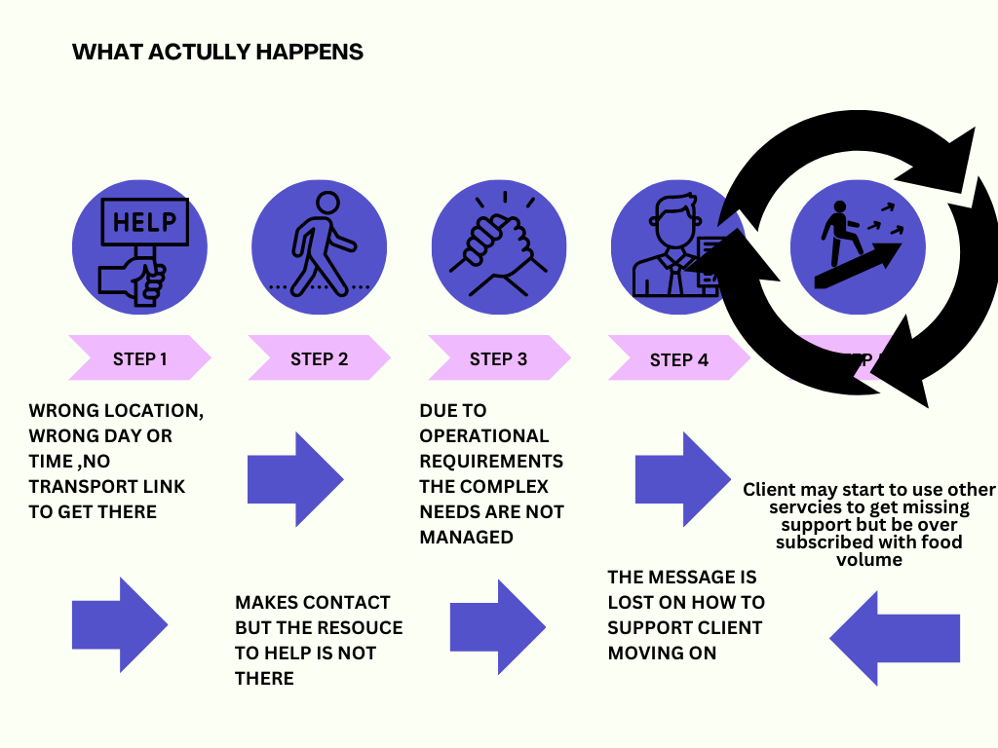

Current Position – West Northants

WNC launched its Anti-Poverty Strategy in 2022, with the vision for a fairer and more inclusive West Northamptonshire, where everyone can live their best life, prosperous and fulfilling, free from poverty and inequality.

Living in poverty has been defined as when a family has a total net income of less than 60% of the median income for their family type, after housing costs.
The Indices of Multiple Deprivation (IMD) shows that 16.9% of the population of West Northamptonshire live in the 20% most deprived areas (LSOA). The area with the highest proportion of residents living in the top 20% deprived areas is Northampton (28.2%) . Further details are in Appendix 2.
The Anti-Poverty Strategy review 2024 shows that:
- Child Poverty: 13.9% of children in West Northamptonshire live in poverty.
- Fuel Poverty: 11.8% of households experience fuel poverty.
- Working Poverty: Over half of those in poverty are from working households.
- Housing Need: 12,049 households are estimated to live in unsuitable housing.
FAAWN is made up of members operating on the following models:

Food banks (crisis support):
- Provide food free-of-charge to people living crisis
- Provide food for a limited period – normally four or five weeks in a twelve-month period.
- Rarely a choice of products, with items being provided focussed on household essential.
- Rarely frozen or fresh.
- Currently 6 sites deliver this model

Food banks (hardship support)
- Provide food free-of-charge to people living crisis
- Provide food for an ongoing period (with no maximum number of weeks)
- Rarely a choice of products, with items being provided focussed on household essential.
- Rarely frozen or fresh.
- Currently 15 sites deliver this model

Food larders (open access/low cost ‘dignity’ shop)
- Provide food for a small weekly charge and an annual membership fee
- Focus on providing food with dignity at the heart of offer.
- Honesty being the main method of determining hardship ensuring no difficult situations for client and volunteers. Mixed message of support and environmental actions
- Focus on social cohesion, often in rural settings with the lack of transport and shops.
- Usually, wider choice of product including fresh and frozen products.
- Customers usually get the choice of products.
- Not always household essentials, focus on providing cheap items that would have traditional gone to landfill.
- Currently 7 sites deliver this model

Food clubs (hardship focused social supermarket)
- Provide food for a small weekly charge
- Focus on providing food with an element of dignity
- Hardship still at the heart with eligibility checks taking place with clear processes in place.
- Usually, wider choice of product including fresh and frozen products
- Customers usually get the choice of products.
- Focus however still on household essentials.
- Currently 8 sites deliver this model (4 only recently transitioned to this model from food bank (hardship support).

All the above rely on support from supermarkets and public donations, and they are increasingly becoming reliant on funding issued by WNC. The network currently supports an average of 500 homes per week which is a mix of single occupants to large families of 6 plus, the volume of users will go up during the winter period by approximately an extra 150 households due to the cost of Christmas.

There are additional food aid organisations outside of the FAAWN network but gaining details on these organisations has been challenging, and there is no data on the numbers of these and what model they deliver. We also currently have a network of charities offering hot food on the street (Appendix 3).

The provision of FAAWN is backed by various VCSE organisations such as the faith backed Trussell Trust to community groups and individuals. All the FAAWN sites, except two, are pop up shops using community rooms or charities sites with some paying rent. Some do still offer a delivered service if circumstances meet the criteria. Each site, while sharing some common goals, is also unique. Infrastructure might be a challenge to some of these groups as the individualistic nature of some organisations are structured around cultural needs and personal choices. Appendix 4 illustrates the services that each setting offer that is funded.

Organisations opening times vary, with most sites open for two-hour slots between Monday to Saturday, opening different times between 9 am and 6 pm. The graphic below illustrates what is available over the week across FAAWN members.

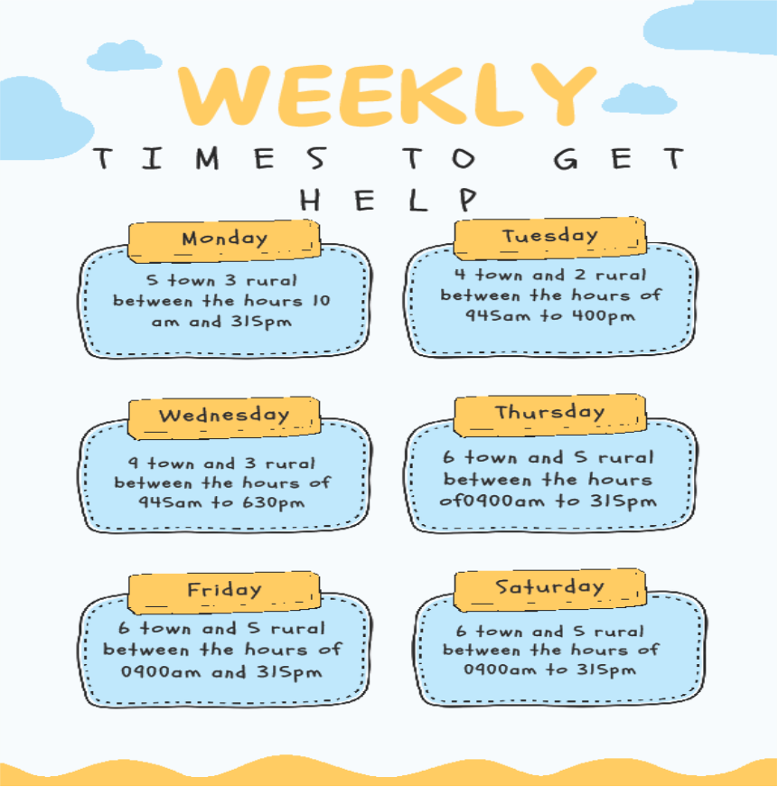

Most FAAWN organisations are promoted locally through social media, especially Facebook, and through local agencies and word of mouth. Schools tend to be where most referrals /signposting occurs.

Food Aid Models

We will now look at the two models the public have to access food, the first being the large supermarkets, and then how the food support network is working to do the same thing.

The retail sector has vast capital investments to get product to market for the public to consume, 94.5% of all food sales are spent with the main retailers. They can control the cost of food due to the multiples of scale.

Model A: Normal retail model for food:

Raw material to supplier to factory to distribution hub to retailer to customer.

Raw Material: The initial inputs or resources are sourced. (Farmers)
Supplier: Entities that provide raw materials to factories. (logistics)
Factory: Where raw materials are transformed into finished products. (Production)
Distribution Hub: Central locations where finished goods are stored and managed for delivery. (logistics and warehousing)
Retail: Businesses or outlets that sell the products to consumers. (Supermarkets)
Customer: The end-users who purchase and use the product.

This gives the ability to buy and produce large volumes of food at low cost.

Model B: Food aid retail model for food:

Due to FAAWN not having the above distribution hub of their own, it means that to access food they rely on more steps and additional challenges and costs.

Raw material to supplier to factory to distribution hub to retailer to customer.

Waste food Buy from retail/wholesale-customer Public donation

Food Aid retail offer

Customer
The added layers makes the model even more challenging for the food aid organisation and reduces their ability to access wholesale reductions and limits the ability to choose what they offer. Furthermore, additional costs are incurred through administrative actions. These include business insurance, maintenance, fuel, employee/volunteer training and compliance with the need for regulations surrounding transport, storage and distribution of food such as:
- The Food Safety Act 1990 – A guide for food business
- The food safety and hygiene regulations 2013
- The general food regulations 2004

Research for this paper

A SWOT analysis was carried out to understand the strengths, weaknesses, threats and opportunities to the current food aid distribution network in West Northampton and help shape the recommendations of this report. Sites visited are detailed in Appendix 5.

Strengths:
- Volunteers
- Community engagement
- Some capacity to accept large volumes of food
- Collaboration as a network
- Ability to react and adapt to local challenges and individual need.
- Established charities in West Northants
- Catering for individual needs
- Some examples of holistic support, especially and money and debt

Weaknesses:
- Ageing volunteers volunteering in a physical environment
- Not able to buy large volumes of food at source to achieve best price
- Too much legislation to comply with limited resources
- Limited sites with poor transport links
- Competition for food
- Lack of fresh food, the landscape is changing due to business’s profits
- Challenge and ability to deal with increased administration
- Inability to store large volumes of food centrally
- Focus on food, rather than individual needs of clients/customers.

Opportunities
- Expand reach with a collective operation support
- To take advantages of support which is currently funded but not used – such debt and money advice
- Share knowledge and skills across the network
- Share volunteering resource
- Use its voice collectively to interact with larger companies for support and funding

Threats
- Increased operational costs
- Lack of funding for staff and premises
- Increase in fuel cost during the winter months
- Food price increase
- Clients/customers becoming dependent on service – food aid enabling financial hardship.

Appendix 6 provides a more detailed overview of some of the common issues identified in the organisations visited and some solutions that may alleviate the challenge. Appendix 7 is the full detail of what was found in each of the visited services.

Observations and Recommendations

The current food aid models and provisions:

The first observation is that all these organisations are doing incredible work. Working with many customers and clients who are distressed and struggling to cope with day-to-day life challenges. Their empathy is outstanding. The food aid network is made up of some of the most caring compassionate people, who are genuinely doing this work (often as a volunteer) because they care and want to make a difference.

More and more clients are becoming reliant on the food aid providers, as there is a lack of wrap around support, to tackle the underlying challenges that led someone to requiring food aid support. Often clients are queuing 60 minutes before they can access food, then the provider is overwhelmed with numbers presented to them. When you have a hub that provides indoor waiting area for example you can start conversations to see what support, you are offering, and they may need.

The Hope centre use a multi-agency wrap around approach for example when dealing with some of the most vulnerable members of society. It works with a clear pathway from crisis to self-dependency whilst working with many agencies to support the pathway. It provides food to engage, not a standalone service. As an example, the Cost of Living Roadshows run by WNC at Woodford Halse demonstrated that a significant number of the public engaged with the services as they had the space to offer the wrap around care in one place.

This means that more and more food aid organisations are only able to address crisis issues rather than supporting the customers/clients to manage the underlying factors. Through the research carried out as part of this project, food aid should never be provided in isolation of ‘wraparound’ support. In the past WNC via FAAWN gave directly to the public in the form of £125 supermarket voucher. This saw a surge in public demand, but the method had no process to follow each client and interact after they had received the payment.

In the summer of 2024, ‘Feeding Britain’ conducted a comprehensive survey of 2,460 service users across their network of Affordable Food Clubs. The survey explored participants' shopping habits, the impact of Affordable Food Clubs on their health, diet, wellbeing, and access to services, as well as the price and perceived value of the goods offered.

The survey found that Affordable Food Clubs have an overwhelmingly positive impact on the health and nutrition of their members; 98% of whom report being able to afford to eat more balanced meals as a result of attending an Affordable Food Club. Alongside supporting physical health, Affordable Food Clubs appear to enhance members' general wellbeing, with 74% reporting improvements since their household began using the service. These wellbeing improvements were most pronounced among members who had received financial advice, or attended social activities, through their Affordable Food Club. Regular attendance at an Affordable Food Club was also associated with greater reported improvements to wellbeing. This highlights the value of a holistic offer supporting people.

Food aid organisations often aim to protect someone’s dignity; in doing so they are not always able to develop understanding of their clients/customer situation. Food aid could be considered as the sole solution but more importantly is an enabler of wider conversation that allows us to directly support or signpost to other organisations that can provide the support regarding the often-underlying factor that led to crisis/hardship.

Food Aid Financial Model

By understanding the needs of our clients, we can move towards a personalised offer.

- Short term crisis support (maximum 4-5 weeks) free of charge whilst other ‘holistic’ support is provided and communication of next steps moving out of crisis – raising awareness of Food Larder services.
- Medium term (5 weeks to 6 months) minimal charging model (10%-15%), providing medium term support whilst assisting clients/customer to take ownership of funding.
- Longer term (6months +) charge of 25%+, providing longer term support whilst person finances are stabilised, but at the same time putting more emphasis on customer/client contribution so that there is more of a focus to customer/clients to taking greater control of their finances.

The opportunity for food aid organisations to provide support and signposting is significant, but it is recognised they need support and training themselves to be able to do this. The Community Training Partnership is a key resource for free accessible and high-quality training that could support organisations. Appendix 8 identifies additional training that food aid organisations need to access to maintain standards. These courses could be part of grant requirements to ensure food standards are meet. Our food aid organisations are well placed to understand the needs of their clients/customer and can support or signpost to appropriate support a more collaborative approach to ensure a uniform delivery across the network.

Food Aid Model Recommendations

    - To support food aid organisations financially and with clear guidance to transfer to the larder model and encourage a more uniform delivery to provide clear data of move on from crisis. – FAAWN
    - Our food aid organisations to embed the financial criteria for clients/customers set out in the anti-poverty strategy, using food aid services for any food aid organisation accessing funds from West Northamptonshire Council to provide a consistent model that has a
clear pathway moving people from crisis to more sustainable situations. FAAWN
    - Ensure training requirement needs for food aid organisations are embedded as part of any grant (Appendix 8). WNC
    - Ensure food aid organisations are accessing Community Training Partnership courses. FAAWN
    - Develop agreed, robust record keeping- data management processes to ensure due diligence and monitoring of impact. FAAWN

Sustainability of the VCSE Sector food aid organisations:

The challenge of sourcing food is a massive part of the week for most food aid organisations. Sadly, as numbers have increased and with less food being made available by supermarkets (food waste/ food surplus), more and more food aid organisations in West Northamptonshire are buying food for its customers/clients. This means that costs are dramatically increasing to meet the current demand.

Initially the idea of running a paid model was resisted (FAAWN WNC agreement section 6) but most now recognise the benefits. Presenting case studies from smaller organisations other than Hope or Food For Thought will be crucial in facilitating this transition. Smaller organisations can show each other you don’t need to be large scale to change to a larder with wrap around support, using agency support already out there.

As suggested in the observations, a new financial criterion is essential to both support clients and to allow each food aid organisation to become more financially sustainable. The income will enable food to be purchased from FareShare or directly from retailers, reducing the reliance on WNC funds.

Currently the main source of low-cost food is available via a national charity wholesaler (FareShare) who is working with food surplus. Although there are other organisations in this market space, few have the size, scale or partnerships of Fairshare. FareShare has no distribution centre in West Northamptonshire or extra capacity to deliver into the area due to their own business model. Further compounding this situation is the reality that food surplus from supermarkets, in West Northamptonshire, are moved out of the county to Fairshare distribution sites outside the county and are supporting other areas and not our own residents.

Due to the success of the FareShare model and national partnership setup with large supermarkets, there is less food surplus available for other local food aid organisations to access. This means that our food aid organisations are having to buy more and more of its food and rely on funding from West Northamptonshire Council to prop up a fragile system.

Although Fairshare does not want an additional hub in our county, West Northamptonshire Council need to influence and advocate to try and bring a Fairshare hub to West Northamptonshire. This may mean some initial upfront costs to support the model, but the cost savings for the food aid organisation of not having to buy food at full retail costs will be significant.

As a national guideline The FareShare membership cost starts at just 27p / kilo collected to 36p / kilo delivered to receive a regular supply of food. On average, FareShare charity members save a huge £7,900 on their food bill each year. This means they can invest in other vital services.

It may be that West Northamptonshire can use its anchor organisation network to support this, with Fairshare heavily reliant on many of West Northamptonshire Anchor organisations already for their food. Although there is no guarantee of success with this recommendation, this action will have one of the largest long-term benefits on the sustainability of the food aid networks. With logistics and especially warehousing being at the heart of the WNC landscape, there is significant opportunities that warehousing for a Fairshare hub could easily be built in to planning condition tied to upcoming initiatives.

Sustainability of the VCSE Sector food aid organisations Recommendations

- We need our food aid organisations to consistently embed the above (section 1) financial model for clients/customers using food aids services for any food aid organisation accessing funds from West Northamptonshire Council. - FAAWN
- We need to ensure funding for food aid organisations is utilised in a consistent approach in line with strategic direction as well as funding guidelines. - WD/Peter Worth
- We need to influence Fairshare or another partner to create a hub / availability in West Northamptonshire to provide long-term access to food surplus. - FAAWN
- Promotion of the model internally and externally (partners and the public) with a clear identity, where and how to access. – FAAWN / All

Wraparound support:

The food offer is currently masking the wider challenges that people are facing. Food aid provision has the opportunity to be used a positive catalyst of change. It is essential that food aid organisations are working to understand the needs of their clients/customers such as:
- Debt and money support;
- Employability and adult learning;
- Immigration;
- SEND;
- Adult social care;
- Housing;
- Mental Health;
- Drugs and Alcohol;
- Gambling;
- Cooking skills;
- Benefits maximisation

Food aid organisations then need to either directly provide support or signpost to available support, so that we can support the underlying challenges that led someone to need to access food aid. It is important that more focus is put on ‘holistic support’, rather than food aid in isolation.

Through FAAWN we need to ensure that food aid organisations are covering the most deprived areas and not duplicating efforts in the same geographical areas but maximising efforts.

The Community Training Partnership has been a fantastic initiative to provide front line workers and volunteers, including those working/volunteering in food aid organisations the basic skills to both engage clients/customers but also to support or sign-post as required. More needs to be done to promote this service to all workers and volunteers in food aid organisations. It is essential that this service is continued.

The greatest support that has been identified is money and debt and benefits, WNC has funded Community Law Service, Citizens Advice and their own internal team to support around this work, but there seems to be a disjoin between this funding and the work of food aid organisations. Community Law Service has made some movement to work collaboratively with a number of food aid organisation in the past year, but there is less partnership with Citizens Advice. It is essential that these services are seen regularly within food aid organisation, and that people accessing the food aid services for free is directly signposted to this service.

Wraparound Support Recommendations

- We need our food aid organisations to understand the needs of their clients/customer, so they support or signpost to support. – FAAWN / CTP / VIN
- Take a collaborative approach to ensure a consistent process is followed across FAAWN to ensure a clear way to report data back and ensure no misunderstanding of what is required. - FAAWN
- We need to ensure that food aid organisations funded by WNC have a clear standard offering of support. To include debt and money, and benefits as a minimum. – FAAWN / WNC to oversee
- We need to ensure that WNC debt, money and benefit advice contracts directly tie into food aid organisations funded by WNC. – WNC
- We need to champion the continuation of the Community Training Partnership and that it is promoted to all food aid organisations. FAAWN / WNC
- We need a direct referral process for safeguarding and vulnerability concerns e.g substance misuse, gambling, housing. FAAWN / WNC
- We need to ensure that all WNC funded initiatives that target individuals or families in hardship are aware of the strategic direction of food aid and look at how they can use the food aid network to reach their target audience. WNC

Conclusions
In a world where nutritious food often remains out of reach for many, Affordable Food Larders (AFL’s) are closing the gap by offering access to low-cost, healthy options. This report highlights the positive impact of these clubs on members’ diets, particularly through increased availability of fresh fruits and vegetables. It goes beyond mere access, showing that when people have consistent access to affordable, healthy food, their dietary habits improve significantly. Additionally, the report outlines the infrastructure needed to sustain this support, facilitated by FAAWN. The global picture won’t be changing soon, so this model is staying part of the support structure.
The health benefits are most notable among those who shop more frequently. Beyond improving nutrition, AFL’s also boost overall wellbeing, often serving as community hubs that connect members to social activities and essential services. These wraparound offerings of holistic support further enhance outcomes, with participation in additional services tied to improved wellbeing, increased fruit and vegetable consumption, and more home cooking education. Notably, food-insecure members are more likely to engage in financial advice and other support services provided by AFL’s. This report shows that the financial relief these clubs offer is a cornerstone of their effectiveness, driving improvements in nutrition, mental health, and quality of life.
While the hubs succeed in reducing reliance on emergency food services and providing vital support to those facing food insecurity, they are not a complete solution. Many members still experience food insecurity, worrying about running out of food or continuing to rely on food banks. This underscores that AFL’s, while innovative and impactful, should be seen as part of a broader system rather than a standalone fix for food insecurity.
The findings emphasize the urgent need for a dual approach: expanding sustainable food provision models like AFL’s and addressing the root causes of food insecurity through systemic policy changes in West Northants and the UK.
A more structured approach between WNC and FAAWN, working more collaboratively and supporting each other to meet the shared goals of a better healthier West Northants is the goal of this report.

Appendices

Appendix 1: Trussell Trust National Landscape picture

A record 9.3million people food insecurity across the UK. This includes 6.3million adults and 3 million children. This represents one in seven (14%) people across the UK and one in 5 children (21%). Current levels are more than a third higher than they were 20 years ago, when 6.7million people faced hunger and hardship. A million more people are facing hunger and hardship in 2019/29 and without change a further 425,000 people are projected to face hunger and hardship by 2026/27. This would increase the rate of hunger and hardship from 14% in 2022/23 to 14.6% in 2026/27

Food insecurity remains a persistent challenge, affecting 13.6% of households as of June 2024.

Research from Trussell Trust showsFood banks in the Trussell Trust network distributed 3.12 million (3,121,404) emergency food parcels in 2023/24. This is the highest number of parcels that the network has ever distributed in a single year and represents a 4% increase on 2022/23.

Over 1.14 million (1,144,096) parcels for children and almost two million (1,977,308) food parcels for adults were distributed over this period. The number of parcels provided for children is largely unchanged from the record levels seen in the previous year, 3 however parcels for adults saw a 7% increase on the previous year.

These figures represent an almost doubling (94% increase) in the number of parcels distributed five years ago in 2018/19 and they are far above the levels seen before the rapid increases in the cost of living in 2021/22 (2.18 million parcels).

Overall, nearly two thirds (65%) of the support provided by food banks in the previous year was for families with children. Families with three or more children are especially likely to face severe hardship, with 30% of parcels provided by food banks in the last year being distributed to families with three or more children. The change in the scale of need is particularly pronounced for these families. Since 2018/19 the number of parcels provided for families with three or more children has more than doubled (106% increase) compared to an 86% increase for families living without any children. In total, food banks supported almost half a million families with emergency food in 2023/24, including 453,000 children and 745,000 adults

In 2022, 3.8million people experience destitution, a level that more than doubled since 2017.

Joseph Rowntree Foundation also suggested in June 2024
- 3.2million people in the UK are only £40 a week from poverty, equivalent to the entire population from Wales. This includes 700,000 children, 1.5 million working age adults and 1.0 million pensioners
- 900,000 of these are only £10 a week away (including 0.2 million children, 0.4 million working age adults and 0.3million pensioners). This is on the top of the 14.2million people already in poverty in the UK, of which 4.2million are children.

In 2021/22 the Trussell Trust supplied 2.2 million three-day emergency food parcels – an increase of 14% compared to pre-pandemic levels in 2019/20. There was a decrease of 15% between the pandemic year of 2020/21 and 2021/22, but the general trend shows a gradual steady increase. The sudden jump in demand during the pandemic put a large strain on food banks with only a short reprieve in spring before the consequences of the rise in cost of living began to be felt.

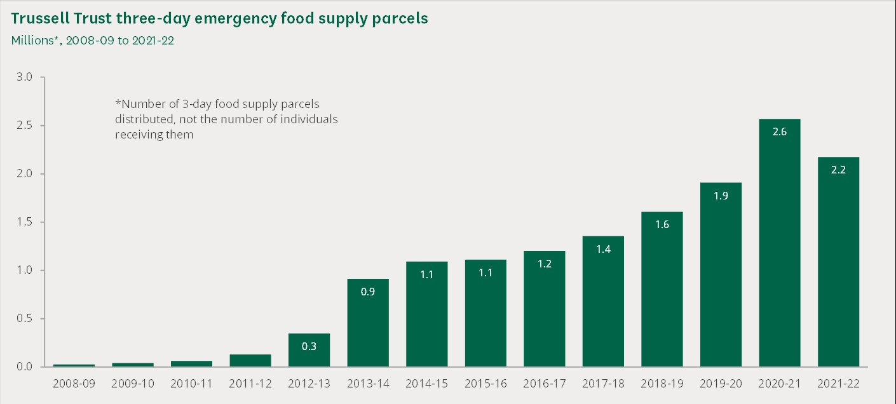

- More people are turning to food banks for the first time
- Between April and August 2022, over half of food banks surveyed by IFAN found 25% or more of the people they supported hadn’t used their services before.
- There are also signs that a wider range of the population is resorting to using food banks – social workers, public sector workers, teachers and people in employment more generally. In June 2022, the National Union of Students carried out a survey of 3,417 students and apprentices. Roughly 11% of respondents had used a food bank, up from 5% in January.
- Families with children are reportedly utilising uniform banks as well as food banks.
Within the context of high inflation and energy costs, charities anticipate demand for food banks will rise further.

Latest data from the Independent Food Aid Network (IFAN) collated from 194 independent food banks operating across England, Scotland and Wales finds:

- Nearly three-quarters of organisations responding to IFAN’s latest survey had seen increases in need comparing November 2023-January 2024 with the same three-month period last year
- 98% of organisations reported supporting people who had not asked for help before
- Most organisations reported an increase in the number of people seeking regular support
- 65% of services had seen a drop in food donations while 45% of organisations contributing to the survey had seen a drop in financial donations
- If demand increases, nearly half of contributing organisations said they would need to reduce the size of the parcels they

Breakdown of IFAN Survey – March 2024
Table 1 – Levels of need from November 2023 to January 2024 compared to November 2022 to
January 2023 as reported by 89 organisations operating 194 independent food banks
Levels of need | No of organisations
Yes, we've seen a increase (roughly 25%) | 41
Yes, we've seen a significant increase (roughly  50%) | 19
Yes, we’ve seen an extremely significant increase  (roughly 75% or more) | 4
Stayed the same | 9
Decrease in need | 11
Other | 5

Table 2 – Reasons behind increases in need from November 2023 to January 2024 as reported by 64 organisations operating 151 independent food banks. Organisations could report any number of reasons.
Reasons for use | No of organisations
Increases in the cost of living | 60
Universal Credit wait times | 47
Inadequate wages | 46
Insecure work | 36
Housing problems | 35
Benefit deductions | 33
Low Social Security payments | 32
Sanctions | 27
No Recourse to Public Funds (NRPF) | 25
Disability related costs | 18
Benefit cap | 17
Transport costs | 15
Two-child limit | 11
Other | 11
Not sure | 3

Table 3 – Supporting people who have not needed help before from November 2023 to January 2024 as reported by 88 organisations operating 193 independent food banks.
Supporting people who have not needed help before | No of organisations
Yes | 87
No | 1

Table 4 – Increased number of people needing regular support from November 2023 to January 2024 as compared to November 2022 to January 2023 as reported by 87 organisations operating 188 independent food banks.
Supporting more people needing regular support | No or organisations
Yes | 67
No | 20

Table 5 – 85 organisations operating 186 independent food banks reported on food donation levels from November 2023 to January 2024.
Food donation levels | No of organisation
Donations levels have dropped | 56
Donation levels have stayed the same | 23
Donation levels have increased | 6

Table 6 – 87 organisations operating 192 independent food banks reported on financial donation levels from November 2023 to January 2024.
Financial donation levels | No of organisation
Donation levels have dropped | 40
Donation levels have stayed the same | 31
Donation levels have increased | 16

Table 7 – 80 organisations operating 170 independent food banks reported on access to surplus food from November 2023 to January 2024.
Experienced difficulties accessing surplus food | No of organisation
No | 43
Yes | 37

Table 8 – 80 organisations operating 170 independent food banks reported on the quality of surplus food from November 2023 to January 2024.
Experienced issues with the quality of surplus food | No of organisation
Yes | 44
No | 36

Table 9 – 89 organisations operating 194 independent food banks reporting on the organisations need to purchase food to supplement for donations from November 2023 to January 2024.
Have you purchased food? | No of organisation
Yes, a broad range | 69
Yes, particular items | 16
No, we have not | 4

Table 10 – Concerns about capacity to provide support if need continues to increase as reported by 88 organisations operating 193 independent food banks.
Level of concern about capacity to provide support | No of organisation
No - confident about being able to access supply to meet demand | 49
Yes - may need to reduce parcel size/voucher support | 24
Yes - may not be able to support everyone seeking our help | 15

Table 11 – The way of operation of the 89 food aid providers operating 194 independent food banks. Participants could choose all options that applied.
Way of operation | No of organisations
Run a food bank or other food parcel distributor | 89
Run advice services alongside food support | 40
Distribute shopping vouchers/cards/energy | 36
vouchers alongside or instead of food parcels
Run a food pantry | 19
Run another kind of food aid service | 16
Other | 13

Table 12 – Ways in which people unable to afford food access the services of the reporting 89 independent food aid providers operating 194 food banks.
 | No of organisations
Referral and self-referral | 57
Referral only | 21
Self-referral only / no records of referrals from outside agencies | 11

Table 13 – Agencies referring people to food aid providers as reported by 78 organisations operating 175 independent food banks. Participants could choose all options that applied.
Referral agencies | No of organisations
Local authority teams (social services, housing, welfare/benefits advice etc.) | 76
Third sector (mental health support agencies, agencies supporting people with NRPF, etc.) | 73
Advice agencies (including Citizens Advice) | 68
NHS services (GP surgeries, health visitors, hospitals etc.) | 66
Schools | 66
Other | 19

Table 14 – 88 organisations running 193 independent food banks reporting on whether Jobcentres have been referring or signposting clients to their services. Participants could choose all options that applied.
Jobcentres have | No of organisations
Signposted clients to our services | 35
Not signposted or referred clients to our services | 33
Officially referred clients to our services | 23

Food aid network used for source of data www.foodaidnetwork.org.uk/data

Appendix 2: Indices of Multiple Deprivation in West Northants (IMD)

The Indices of Deprivation are a unique measure of relative deprivation at a small local area level (Lower-layer Super Output Areas) across England and have been produced by the ministry of housing, communities and local government. The Indices of Deprivation 2019 (IoD2019) is the most recent release. The Indices provide a set of relative measures of deprivation for small across England, based on seven different domains, or facets, of deprivation:

The table demonstrates Local Area Partnership details.
Indicator | Northampton Central | West Northamptonshire | England
Index of Multiple Deprivation 2019 (IMD) Score (2019) | 31.06 | 17.68 | 21.76
Index of Multiple Deprivation (IMD) 2019 Rank (2019) | 8,990 | 19,202 | 16,356
Indicator | Northampton East | West Northamptonshire | England
Index of Multiple Deprivation 2019 (IMD) Score (2019) | 29.56 | 17.68 | 21.76
Index of Multiple Deprivation (IMD) 2019 Rank (2019) | 11,465 | 19,202 | 16,356
Indicator | Northampton North | West Northamptonshire | England
Index of Multiple Deprivation 2019 (IMD) Score (2019) | 21.23 | 17.68 | 21.76
Index of Multiple Deprivation (IMD) 2019 Rank (2019) | 15,691 | 19,202 | 16,356
Indicator | Northampton South | West Northamptonshire | England
Index of Multiple Deprivation 2019 (IMD) Score (2019) | 14.05 | 17.68 | 21.76
Index of Multiple Deprivation (IMD) 2019 Rank (2019) | 21,862 | 19,202 | 16,356
Indicator | Northampton West | West Northamptonshire | England
Index of Multiple Deprivation 2019 (IMD) Score (2019) | 18.07 | 17.68 | 21.76
Index of Multiple Deprivation (IMD) 2019 Rank (2019) | 17,755 | 19,202 | 16,356
Indicator | Rural East | West Northamptonshire | England
Index of Multiple Deprivation 2019 (IMD) Score (2019) | 7.66 | 17.68 | 21.76
Index of Multiple Deprivation (IMD) 2019 Rank (2019) | 27,359 | 19,202 | 16,356
Indicator | Rural North | West Northamptonshire | England
Index of Multiple Deprivation 2019 (IMD) Score (2019) | 9.85 | 17.68 | 21.76
Index of Multiple Deprivation (IMD) 2019 Rank (2019) | 24,928 | 19,202 | 16,356
Indicator | Rural South | West Northamptonshire | England
Index of Multiple Deprivation 2019 (IMD) Score (2019) | 7.21 | 17.68 | 21.76
Index of Multiple Deprivation (IMD) 2019 Rank (2019) | 27,700 | 19,202 | 16,356

Appendix 3: Free Food and drink in Northampton

Day & time |  | Where | What
Monday at 7pm |  | Top of Abington Street | Hot food and Gregg’s coffee, tea, hot chocolate, clothes
Tuesday  5.30pm |  | Outside the Library, Abington Street | Hot food like jacket spud, cheesy or tuna pasta. Snack bag with chocolate, crisps, sandwich, water/juice and hot drinks available. Occasional cakes and clothing on offer.
Tuesday  6-8pm |  | ST James Church | Sit down hot meal and desert in the Church including hot drinks and juice. Can take 4 items away with you and access clothes which are free.
Wednesday |  | No food at present
Thursday |  | No food at present
Friday  6-8pm |  | ST James Church | Sit down hot meal and desert in the Church including hot drinks and juice. Can take 4 items away with you and access clothes which are free.
Saturday  6.30pm |  | Opposite Poundland outside the Scope shop | Choice between 3 hot meals, Greggs, hot drinks and occasional dessert. Sleeping bags and tents if they have any in.
Sunday  11.30am |  | Behind the job centre | Hot and cold drinks and food
Sunday  12.30pm |  | Outside Costa/Metro Bank | Hot drinks and food
Sunday  6pm |  | Outside All Saints Church | Hot drinks and food

Appendix 4:
4.1 Current food services offered by FAAWN members receiving grant money from Public Health

Name | No. of Sites | Food Bank Crisis | Food Bank Hardship | Food larders  Paid membership | Food club  No paid membership | Hot Meals
Restore | 6 | Yes
Hope | 4 | Yes |  |  | Yes | Yes
FFT | 7 | Yes |  | Yes
SNVB | 2 | Yes |  | Yes
Impact now | 1 | Yes | Yes |  | Yes
Right resolution | 1 | Yes
Bugbrooke | 1 | Yes |  |  | Yes | Yes
St Davids | 1 | Yes |  |  | Yes | Yes
UUA | 1 | Yes | Yes |  |  | Yes
1857 | 1 | Yes |  |  | Yes
Castle Hill | 1 | Yes | Yes
Springs | 1 | Yes | Yes
Community Spaces | 1 | Yes | Yes
McCarthy Dixon | 1 | Yes | Yes | Yes
Weston Favell FB | 1 | Yes
Milk and Me | 1 | Yes
Cooking good | 0
C2C | 1 | Yes
Life Chapel | 1 | Yes | Yes
Shine | 1 | Yes | Yes
Three Pillars | 1 | Yes | Yes |  |  | Yes
SYCCY | 1 | Yes | Yes |  |  | Yes
RBN | 1 | Yes | Yes
4.2 Name and locations of current FAAWN members receiving Public Health money
Name | No. of Sites | Location | Information
Restore & Partners | 6 | Town centre/Spinney Hill/Duston/Briar Hill/Broadmead avenue/Far Cotton | All work with multi agency's for a set amount of help per year
Hope | 4 | Town centre x2/ Dallington/Blackthorn | 3 food clubs with homeless centre
FFT | 8 | Brackley/Helmdon/Daventry x2/Woodford Halse /Brixworth /Moulton | Paid membership with weekly pay as you go
SNVB | 2 | Towcester/Rhode | Paid membership with weekly pay as you go
Impact now | 1 | Town centre tbc | Crisis support with delivery and food club
Right resolution | 1 | Multi-site care leavers | Supporting care leavers
Bugbrooke | 1 | Bugbrooke | Low-cost food club with café
St Davids | 1 | Kingsthorpe | Low-cost food club with café
UUA | 1 | Town centre | Low-cost food club with café
1857 | 1 | Barret road | Low-cost food club with café
Castle Hill | 1 | Spring Boroughs | Crisis support with delivery service
Springs | 1 | Spring boroughs | Crisis support
Community Spaces | 1 | Briar Hill | Crisis support
McCarthy Dixon | 1 | Town centre | Independent supporting school holidays with food larder on site
Weston Favell FB | 1 | Weston Favell shopping centre | Trussell trust backed set amount of support per year
Milk and Me | 1 | Daventry outreach work | Support for people with young babies with hot meals and essentials
Cooking good | 0 | Multi- site work shops | Cooking workshop support
C2C | 1 | Town centre | domestic abuse support
Life Chapel | 1 | Town centre | Cultural food support
Shine | 1 | Town centre | Cultural food support
Three Pillars | 1 | Duston | Supported by the mason's hot meals
SYCCY | 1 | Str James | Crisis support with deliveries and a monthly charge
RBN | 1 | Town centre | Crisis support but only monthly

Appendix 5: Locations Visited for Research

The first set are making the first step to be sustainable working towards a 10% cost price:

- Impact Now, food bank offering Community Support Program
Supporting the families of children enrolled in educational programmes to enable them to overcome financial, social and health barriers that can impact on their children. Impact Now will be starting their larder project this November, using a site supplied by NPH.
- Café 1850, food bank which has started to charge for service, faith backed.
- St. David's, food bank and low-cost cafe warm space in a church community room.
- SYCCY, vegetarian food bank, Community Kitchen, Shielding Support, Prescriptions and grocery shopping, Information, translated advice, advocacy, referrals, and BAME culture specific support, Resources: Clothing, household, toiletries, and hygiene products
Support and Poverty – Social Action Appeals: Hamper events for deprived clients; Sewing PPE for NHS staff; knitting woollies for elderly warmer winter appeals; Environmental campaigns

N.B SYCCY has a permanent building which is a community hub, which could expand its services.

The next set are currently nonpaid models:

- UAA, food bank Welfare support immigration grow cook eat IT CV physical activities based on African cultural values Castle Hill Church, food bank offering support to local primary school.
- Far Cotton, food bank with warm space and café based in a church.
- The last one is a sustainable model based outside of Northampton
- SNVB, food larder with environmental ethos, has collaborations with other services
- Housing support for grand union houses citizen advice food bank referral mental health.

Additionally, I have extensive experience with both Hope and Food For Thought (FFT) operations as sustainable food club/larder models.

The FAAWN network offers wrap around care from, financial support to wellbeing, growing and cooking food, CV writing classes and employability sessions, it is the more established sites that offer this due to the location, numbers of volunteers and links to organisations offering trained advice (Community Law Service/NPH/WNC Customer service Team/ Hope).

Appendix 6: SWOT core themes analysis and mitigations
Current issue | Impact on service | Mitigation to this challenge
Volunteer numbers low | Services will get affected and become irregular | Use known resources and organisations to improve numbers and make this a FAAWN / WNC priority
Working in silos | Opportunities will be missed | Promote great work already done  Shared plan of development for organisations e.g. training
Not enough collaboration | Trust isn’t built to work together | Promote great work already done.  Opportunities for coproduction across organisations.
Inability to buy food collectively | Always paying the supermarket prices | Look at group buying power
Dealing with legislation | Potential to be closed by EHO | Work with EHO and understand avenues of support in this area.
No joint strategy on locations | Support not in the right place | FAAWN could address this through mapping of needs and insight.
Output of food higher than input | Volume of food will reduce, and new clients not supported | More time spent looking at alternatives  Consider how FAAWN can collectively obtain better food.
Competition for food at its highest | May be left with unhealthy food, promoting poor diet | Promote current programme Grow, Cook, Eat  Consider how FAAWN can collectively obtain better food.
Companies not wasting as much food | Less easy food available for collection | Look at group buying power
Grants come with excess administration | Poor culture remains | Faawn works better as a single point of contact in lines of communication with WNC
Inability to store large volumes of food | Large volumes will go elsewhere | Look at group solutions
Wanting to offer a retail feel | Creating a false environment which can't be fulfilled. | Be more realistic of the food offer

Appendix 7: Detailed SWOT reports for each agency researched

A SWOT analysis is a framework for identifying and evaluating an organization's strengths, weaknesses, opportunities, and threats.

The set of slides are a broad look at FAAWN as a body of food organisations currently working in West Northamptonshire.

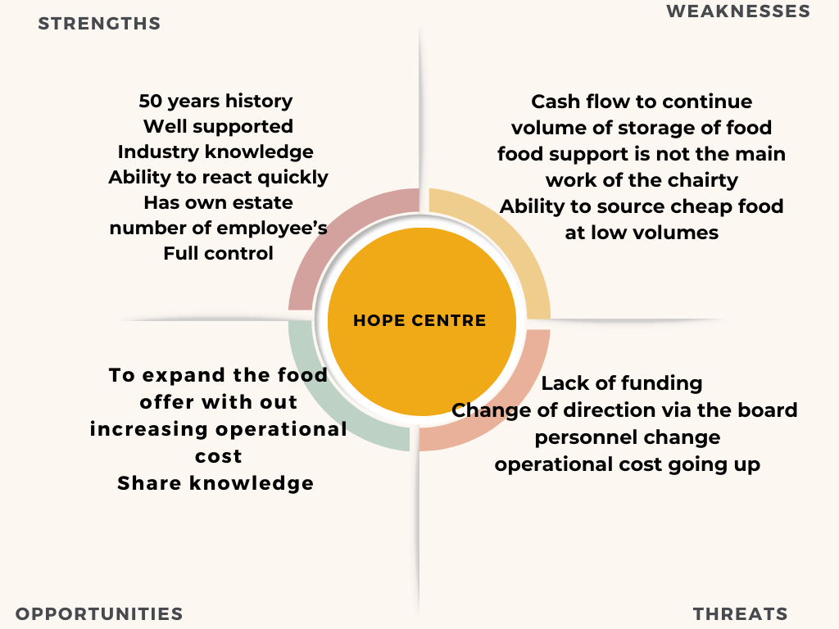
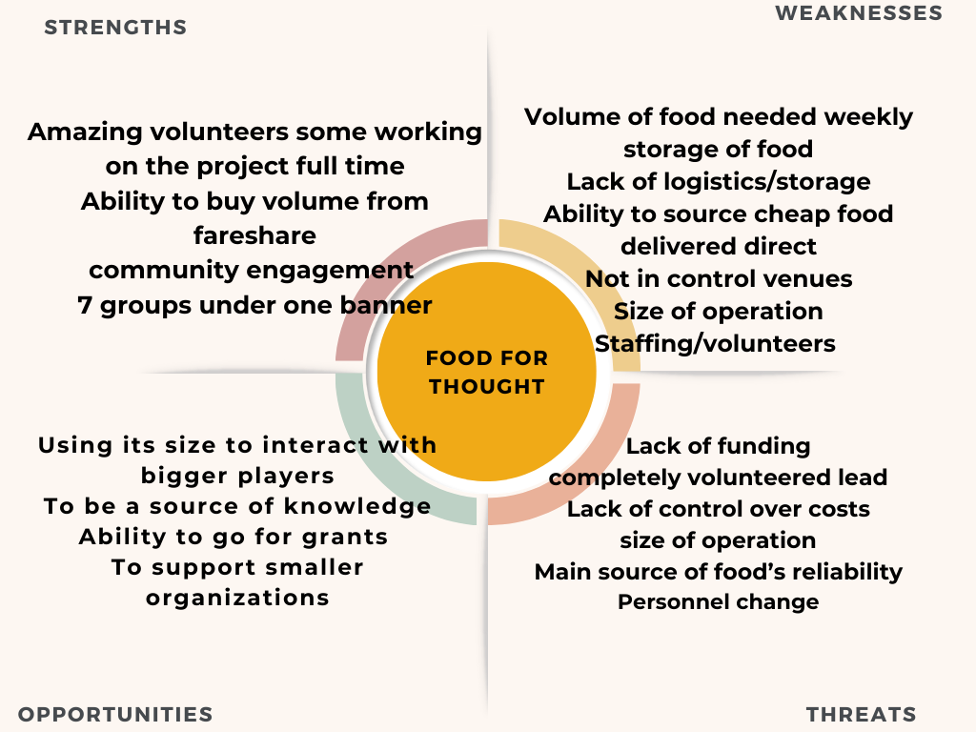

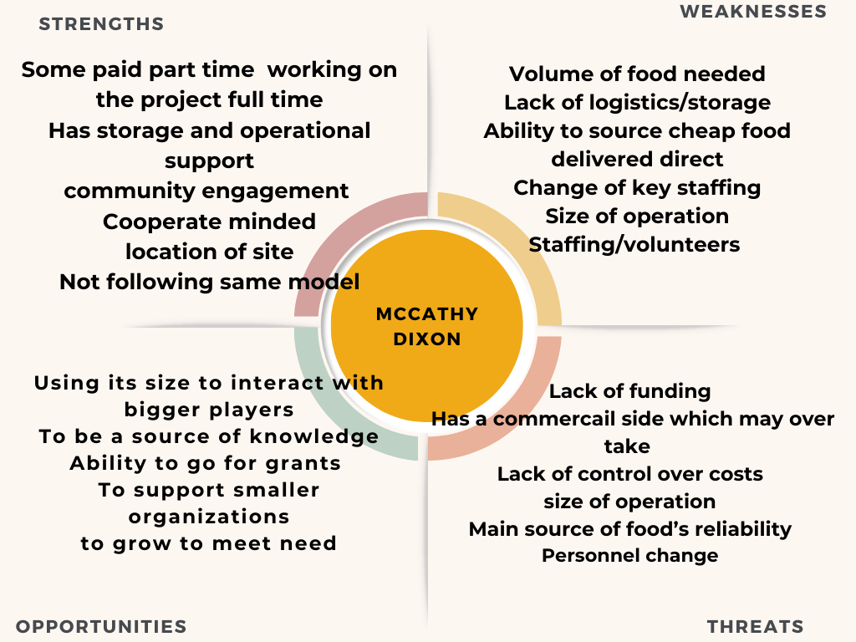
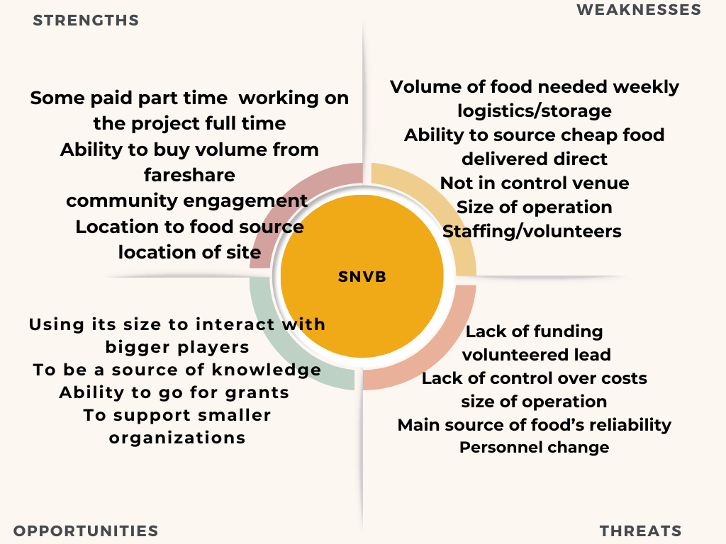
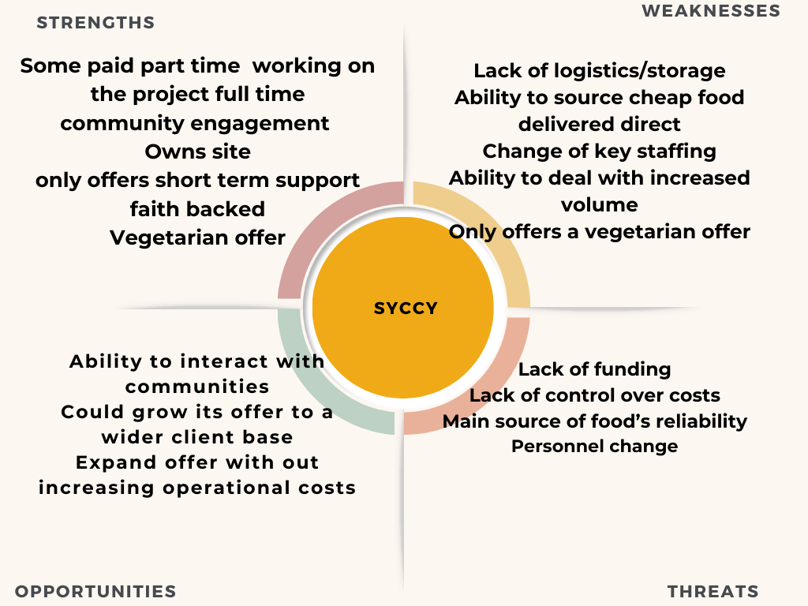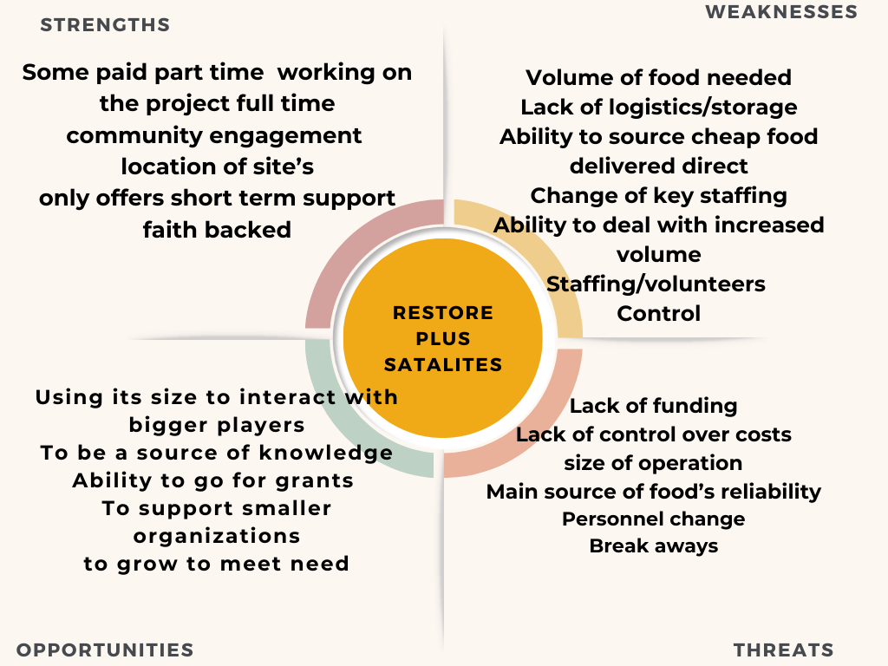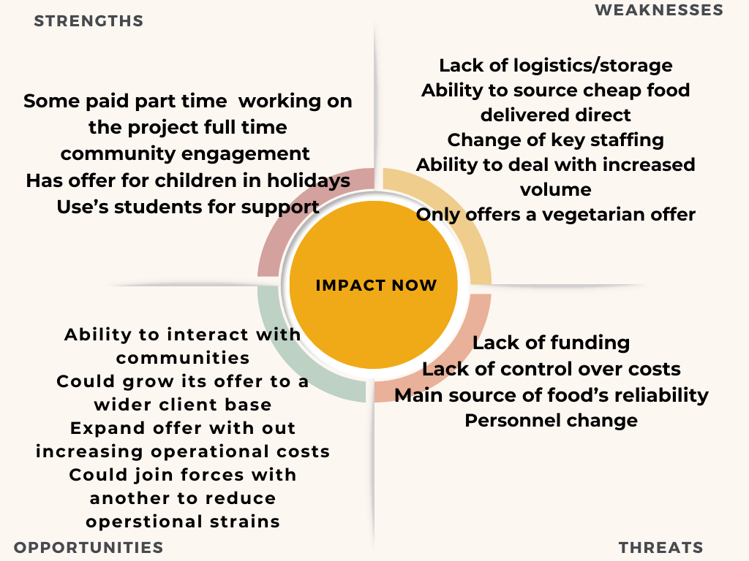
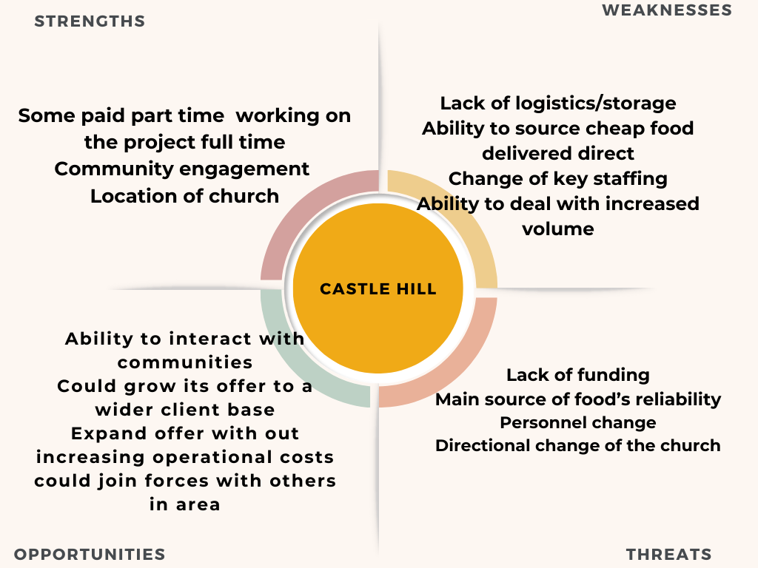
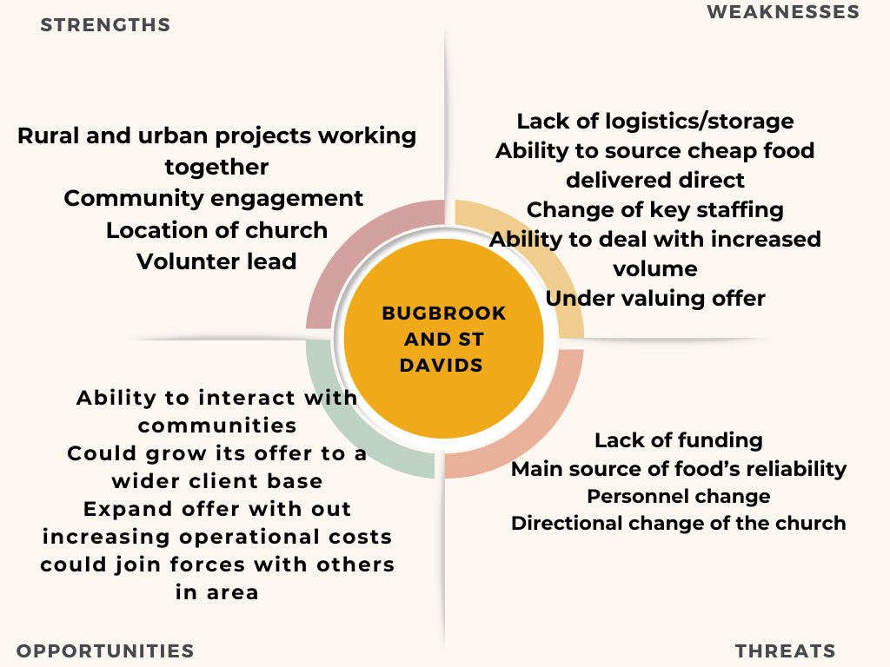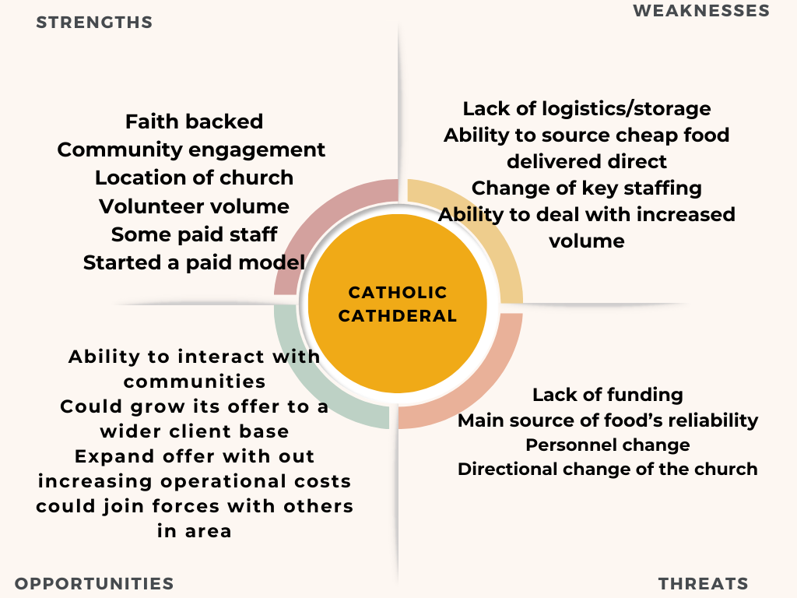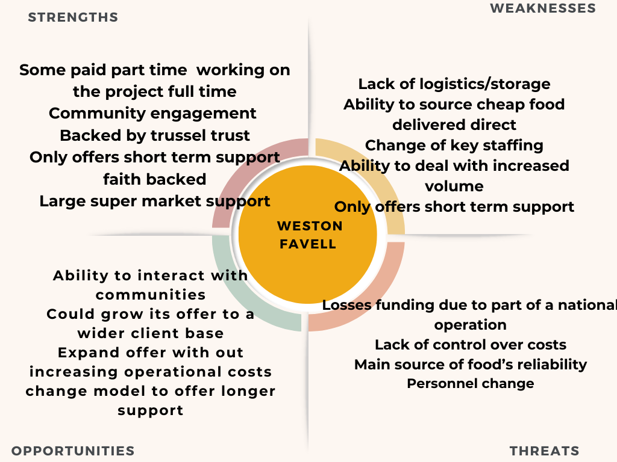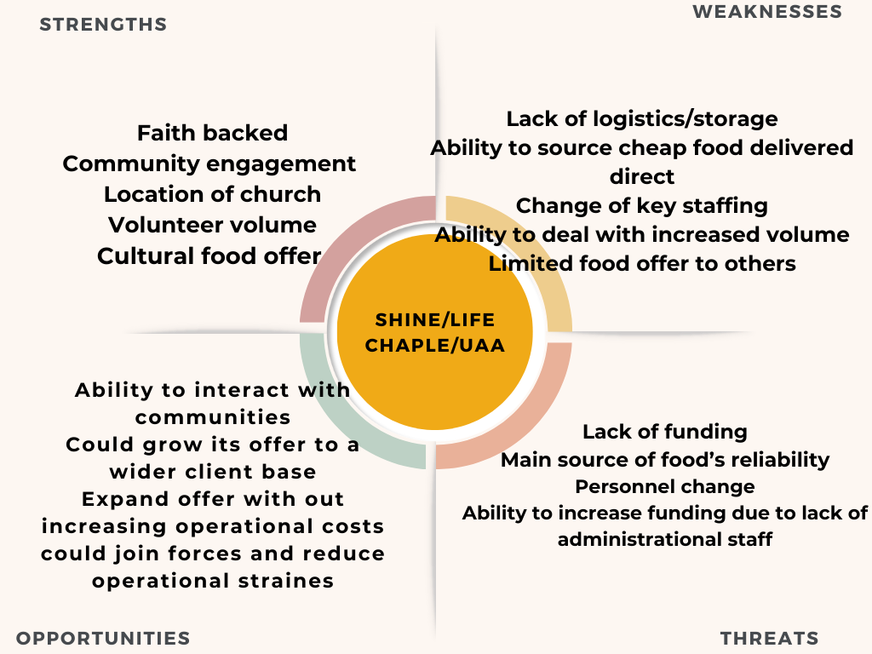
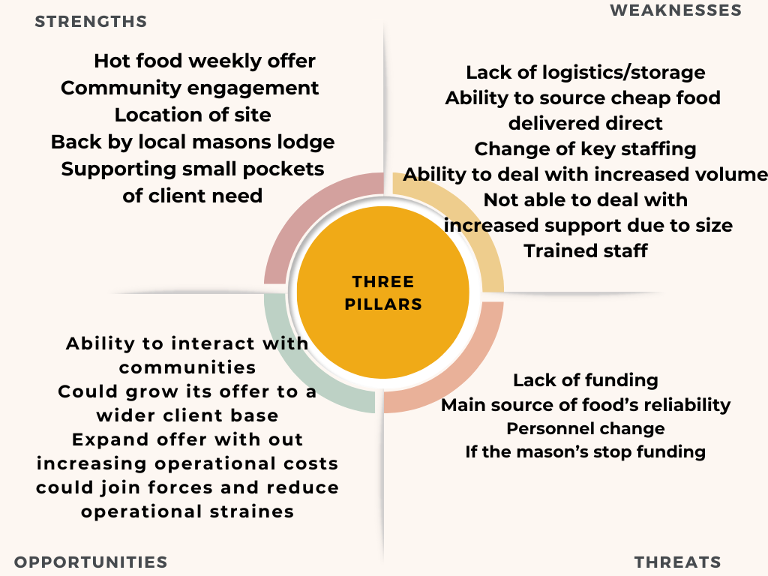
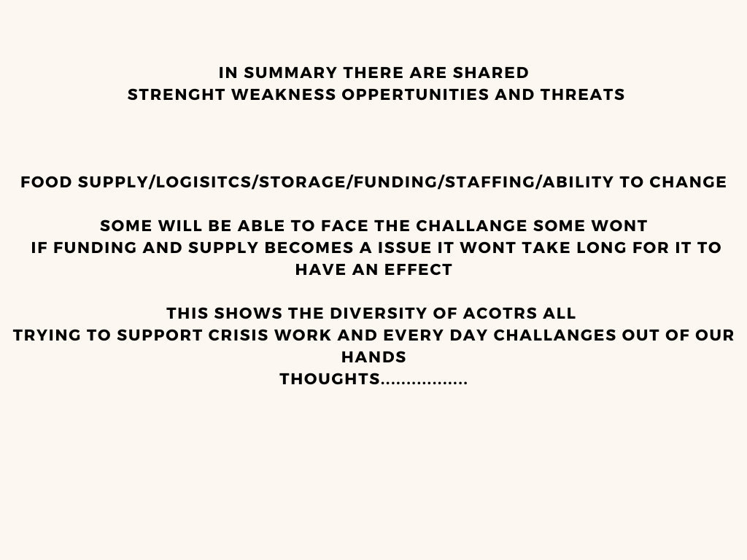

Visit notes from the SWOT analysis.

Impact now notes:
Over 90% deliveries in her own vehicle, £400 plus a month for three units when they could use a pallet store and work stock more efficiently. Using funds from hsf4 and other grants as buying best priced good from other sources, but this is still time consuming. Spoke about not underestimating what they do for the clients, and to re word that their service is worth a paying model, from this I have encourage a delivery charge to at least cover some of the logistical cost. This will have some impact as seen by hope, but the value of the service needs it profile lifting as not to encourage client under appreciation of what goes in to getting the food to them. The average bag cost seems to be higher than reported and ill estimate it is £10 to £12 pp they are supporting large households of 7 plus.

The number of food parcels is every three weeks, but some are more than that, with this in mind Nike has been getting pressure to look at the paid model internally and has taken this on board and we have arranged a visit to Kings Heath to see the impact of a fc and the benefits to the client and the organisation to be more sustainable. Collected food from the ST James coop only one currently but with showing methods to save time and money this could be improved. They are in desperate need to find an allotment; they are incredibly keen to get a growing project off the ground. They are asking the questions to the client as its not time efficient to go door to door. I can review this on volume and quality of responses.

Very positive that this will roll into a paying model and have offered space at hope on a Friday to trail their own fc.

Shine notes:
Small selection of food available open 3 hours and will do 6 clients. Change model to every 2 weeks and offer delivery mainly to people with health issues. Do vet clients and filter out if they feel the client does not need help. Very little on collections due to quality available and client’s complaints. No chilled/ frozen, in the past have offered African food but not sure if that it's needed or because it's free.

Possibly join with another organisation to be more effective, no reel offer of other support will introduce the NHS drop ins at hope due to inherent health issues and the lady from farm foods. Send questions very welcoming double check bag price.

4u community notes:
Great set up, the room is perfect for a community hub. Have started to charge per shop but are under valuing what they do with the low cost of a £1 and giving more to a family but for the same price. Main bulk of customers are on benefits, and they let the client shop twice a week (need to check this). Making bags up which is time consuming but have limited storage at the church. Have spoken about change and it's a bumpy ride and they would have a challenge with the volunteers moving to a larder, but I think I could do it. Need to check the bag cost, but the team are so engaging it’s a pity the com law and NPH don’t work Saturdays. Saw some of our Hope clients and also felt I saw a KH shopper also who would benefit from his church.

UAA notes:
Local community centre food bags given along with a meal, Anne is concerned about finding will send questionnaire, not a straightforward food bank very cultural, did see raw meat will email Anne. No clients seen only volunteers, as clients only turn up until hot food ready need to go later to see what's happening. I was concerned to see boxes of meat being taken into the building, will pick this up. Check bag spend and numbers again would suggest combining with another if they could move to a bigger site locally.
1. Average home deliveries pw = 45
2. Average attendance/ collection = 50
3. More than 6 free meals in a 12-month period = 100 Households, each with an average of 4 family members
4. Other services offered include, online wellbeing sessions, immigration information (sign posting) to Red Cross and Community Law, swimming sessions for ladies, football sessions for young boys and adults, drumming sessions, warm spaces, allotment participation, IT sessions for beginners and improvers. We also have weekly online wellbeing sessions on a variety of topics including diabetes, isolation, nutrition, debt advice.
These sessions are facilitated by qualified professionals, we also have a volunteer counsellor on the team. We also give advice to people who are homeless or are facing eviction, we help them secure accommodation where possible. The majority are not eligible for homelessness assistance from Hope due to their no recourse to public funds or immigration status. Lately, we have been having an increasing number of Sponsored Skilled workers coming with work and unemployment worries, mental health issues, money worries, immigration concerns, modern slavery and exploitation reporting etc. We also facilitate monthly one to one meeting with Citizens Advice Bureau at our offices.
Castle Hill notes:
No Liz or Tracey on site, the food bank is set up from a small room where the stock is bagged up. It looked like to bags for life for each person some collected some delivered via a school. No fresh or temp controlled, was informed that they were taking an extra 10 to the school but when I asked if they been registered was told that she knew them all, so it wasn’t a problem. A church elder was interested in my questioning so spoke to them about what I was doing and thanked them for my time. They are defiantly supporting people weekly, and I’m concerned over data until I’ve seen it. I don’t think Liz and Tracey are together until the 15th Aug. Will email to speak to them today.
Visit to castle hill@the headlands 12/08/2024
Visit with Rev Liz and Tracey, explained the ph role and that there is no ties to FAAWN as it is two separate projects which opened up the conversation. What was good was to hear that they are policing who uses them and are looking at the bigger picture, same as everyone else they are the strength and the weakness in the picture. They have a sum of money to spend if I help them buy bulk from Aldi not to lose the fund they can generate the money to pay off storage buy becoming a larder. Still running crisis alongside a paid model will reduce the number of people who and being kept where they are and not moving forward, the headland is an underused facility but is having a face lift in 2 years.

The main church in town is a fantastic building and gave tips to get local support to transform what is required. The church has a famous past priest with a tie to America which they get visitors to see what their is could be used to really push the hub in a area of town needing the support. Change in their own walls is the church elders who must get every passed by them, so I may have to do a presentation to them to get this one over the line. Have suggested a visit to spence late September, with a view to a trail November hopefully tying in help with the 38k.

SYCC notes:
Visit to waterside SYCC with Pindy.
Very impressed with the down to earth approach and honesty, the volunteer training includes what to look for with clients and to ask question and review who is using the food bank. The client base seems to be the bottom of the pile, if the deliver to a door with a nice car on and designer clothes they will seek to ask the questions and to determine what the need is. The centre has gym facilities and groups with hot meals being produced to feed the elderly, and not just the Sikh community. Heavily rely on volunteers and funding for food but at the ground level deal with cultural food needs which can’t be ignored and even find funding to increase fresh into the weekly support.

Everything under one roof is perfect to take the journey to recovery. Have a mix of clients who need delivery to walking in and getting food, current model sustainable until December and then will need to look for support have reduced the size of bags (check David on size) Pindy was very open to the possibility of running a paid model alongside crisis work. Didn’t see any use of surplus food but honestly didn’t ask either. Rama is back while I’m away will set up another meeting beginning of September.

13-11-24 Visit with Rama FB lead. We discussed ways that the food bank could integrate with the crisis work, very successful she will visit blackthorn with me to see the workings of it. They are currently reviewing the impact of what they do and the output. This is a very exciting project as they have the site to become a hub.

Café 1859:
Have started a paid model and have embraced the ethos of the paid model running along crisis work. They have found their own identity and method and have seen a real increase in peoples dignity and a centre for the community in Semilong. What’s on their side is the backing of the diocese with the facilities, but not funding which they raise with jumble sales and quiz nights, they are also working with other agency’s i.e. toy swap to enhance the offer to the client. They need support in keeping in the loop as they missed out on the hsf5 funding, currently don’t rescue food due to the poor quality but also infrastructure of access to the building in the evening and the age of volunteers.

They have a van which is used to collect the food from store and to help with other aspects of need i.e. furniture. Great team who could do with guidance on better ways to access funding but they do have the diocese behind them, they are as ever one else doing the best to prevent dependency and asking the right questions to build reliance and to offer short term support to give back responsibility to the user. Is very willing to show case to others how they transitioned to a paid model and the benefits to doing it. If there was no funding though I don’t think they would be able to carry on.

Far Cotton notes:
This is how a church room should be used, if only in the summer months. Walked into food, clothes, tea and cake and a kids play area, wow if more churches would do this. (boiler broken so that’s the next big drive) have seen a swing from families to mainly single men with dietary challenges of not being able to cook. This did lead to a conversation on grow cook eat, and also being a restore hub were defiantly up for running crisis along side paid model Liz to arrange a visit to spencer in September. Very multi-cultural and very part of the community, have past on com law details have suggested ideas for other agencies but the building in colder weather is not fit for purpose due to the high cost of heating. Great team and asking the right questions but as other organisations its hard at the coal face to over police the cohort coming in. As I was leaving a midwife came in support a single mum who had no food great that they were able to help and ha d fc support flyers on hand to help people back on there feet. Even saw a fc member who is getting better support for them as they have a small child. Plans to turn part of the church into a catering offer but need to raise fund to do, again church support but no funding for the work.

SNVB notes:
Great site and team working hard, they are working on all aspects of food from waste to crisis support. One massive negative is the building is potently being sold, with no alterative on offer which if this happens will leave a hole for client and for food that access due to location. They are high numbers and they are showing clear lines of crisis support and saving food for waste with signage in the shop area. They are offering a paid model with free support, fall into the same boat as others that moving people on is hard due to the need they are seeing and the amount food they have to give out. If they could get funding for a building that would be a start. Have their own CRM system which tracks the client which could be used for others as it is a clear pathway.

Appendix 8: Training Consideration
Running a food aid organisation involves a combination of organisational, logistical, and customer service skills. While there may not be formal qualifications required, specific training and preparation can help you run it effectively. Here's a breakdown of the key areas of training and preparation that could form a programme:
A. Food Safety and Hygiene
Since there is food handling, food safety is critical. Training in this area ensures that food is stored, handled, and distributed in a safe and hygienic manner to prevent contamination or illness.
- Required Training: Basic or advanced food safety and hygiene courses (depending on the type of food you handle). You might need Level 2 or Level 3 Food Hygiene certification.

B. Volunteer Management
Food larders often rely heavily on volunteers to help with daily operations. Managing and training volunteers requires leadership skills.
- Required Training: Courses or workshops in volunteer management, leadership, and team coordination.

C. Health and Safety
The food larder environment needs to be safe for both volunteers and clients. Understanding risk assessments, fire safety, and first aid is important.
- Required Training: General health and safety training (sometimes required by law) and possibly first aid certification.

D. Customer Service and Communication
Since working with diverse groups, often including vulnerable individuals, having strong communication skills is vital. Training in customer service can help manage difficult situations, address client needs, and maintain a welcoming atmosphere.
- Required Training: Communication skills workshops, conflict resolution, and customer service training.

E. Fundraising and Budgeting
Many food larders depend on donations and grants. Basic training in fundraising, grant writing, and budgeting will help ensure sustainability.
- Required Training: Workshops or online courses in fundraising, non-profit management, or grant writing.

F. Logistics and Inventory Management
Running a food larder requires good organizational skills, especially when it comes to stock control, food rotation, and ensuring the larder is adequately supplied.
- Required Training: Supply chain management, inventory control, or basic logistics/warehouse training.

G. Understanding Local Regulations
An awareness of local laws governing food distribution, health, and safety regulations needs to be understood. These can vary depending on your country or region, so familiarizing yourself with local guidelines is crucial.
- Required Training: Information on local laws, usually offered by local government agencies or non-profit organisations.

H. Cultural Sensitivity and Inclusion Training
Working in a food larder often means interacting with people from diverse backgrounds, many of whom may be experiencing hardship. Training in cultural sensitivity, mental health awareness, and inclusion can help provide a respectful and effective support system.
- Required Training: Cultural competency and mental health awareness courses.

Reports referenced:

……………………………………………………………………………………………………………………………….
Feeding Britain- The impact of Affordable food clubs on Nutrition and Wellbeing 2024
Anti-poverty strategy WNC
The Food Foundation (2024) Round 15. Food insecurity Tracking

The Food Foundation (2024) Round 15. Food insecurity Tracking
Food aid network used for source of data www.foodaidnetwork.org.uk/data
Trussell Trust - Cost of hunger and hardship Interim report 2024_4.pdf
The Food Foundation (2024) Round 15. Food insecurity Tracking
Trussell Trust UK Fact sheet - Emergency food parcel distribution in the UK 1 April 2023 to 31 March 2024
Fitzpatrick, S, et al (2023) Destitution in the UK 2023, Jospeh Rowntree Foundation.
https://www.jrf.org.uk/news/nearly-1-million-people-only-10-pounds-a-week-away-from-poverty

